
Technoprenurship portfolio T25
EAE7503-A

IDEA GENERATION STRATEGY
Our strategy for developing our ideas was born from our own personal experiences as first-hand customers and developing a solution/product that answers a need. Using mind mapping, opportunity identification, reverse thinking, swot analysis, we came up with the following idea concepts. Our ideas provide innovative changes we would like to see in existing products as a customer and hopefully address certain market gaps.

Figure 1 AN ILLUSTRATION OF MIND-MAPPING
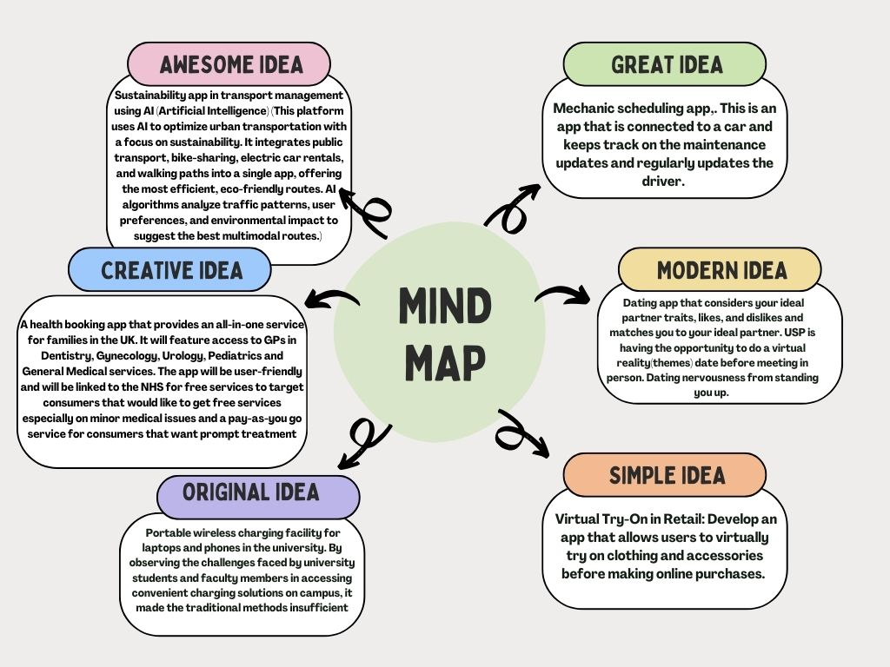

Inspiration for REVIVE
Being international students, many of us have faced challenges accessing UK's health care facilities (NHS). Whether it is accessing basic healthcare such as scheduling a general practitioner appointment or visiting specific healthcare specialists for various medical issues.
This led the group to devise a solution, in the form of an application that eliminates all the roadblocks that patients face when booking consultations and appointments. The main goal of this application is to provide a streamlined booking process and access to various medical specialists for a more convenient user experience.
We hope to integrate Generative AI into REVIVE to significantly enhance user experience and provide a high level of personalized healthcare services.

Ideation
For Ideation, we used the business validation framework to narrow down our ideas and decide which was the best option using the questions below.

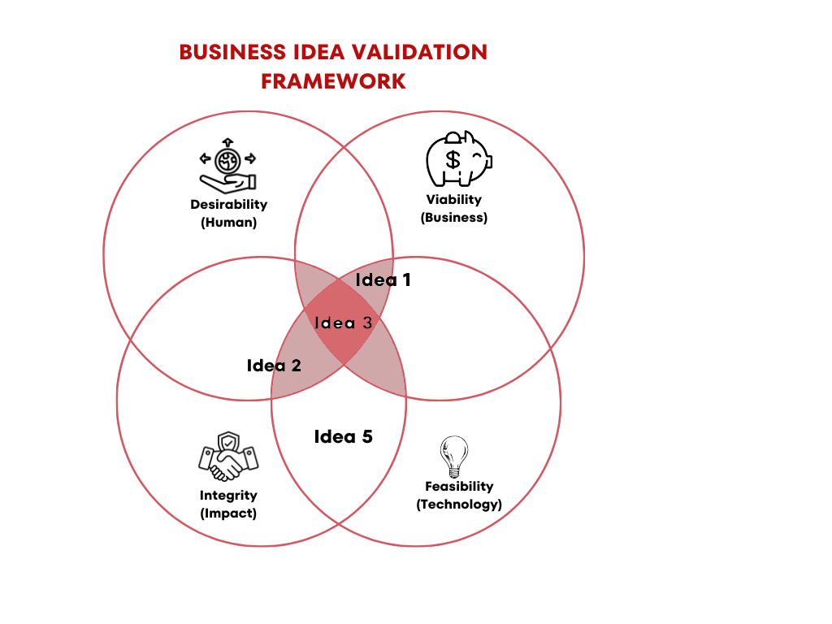
- Feasibility: Can we do it?
- Viability: Can we make money out of it? Will it be sustainable and scalable?
- Desirability: Do people want our product or service?
- Integrity/Ethics: How does our product impact society and the environment?

We also used the Lemonade theory and Empathy map for our Ideation process.

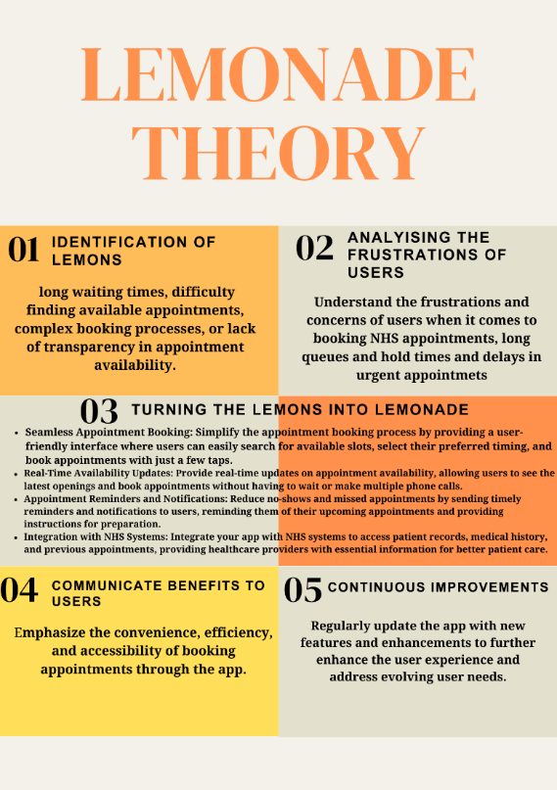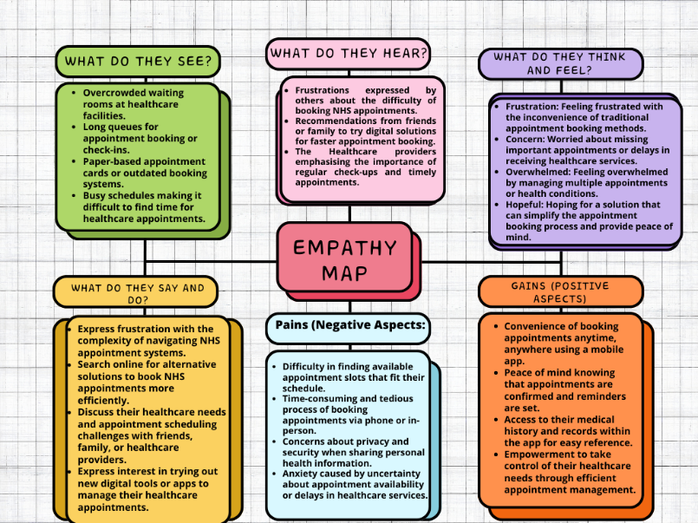

OUR TECHNOPRENEURSHIP SOLUTION



A health booking app that provides an all-in-one service for families in the UK. It will feature access to GPs in Dentistry, Gynecology, Urology, Pediatrics and General Medical services. The app will be user-friendly and will be linked to the NHS for free services to target consumers that would like to get free services especially on minor medical issues and a pay-as-you go service for consumers that want prompt treatment. It will be designed in compliance to data and privacy health regulations and each GP will be verified with a license to practice in the UK. The app will log patient history, referrals, and medication subscriptions with notifications for upcoming health checks and treatments. The app will be interactive and have secure payment options, virtual/video consultations, and a feedback section post appointment.

Desired features of REVIVE (USP)
There are 4 aspects to consider in developing our health app, so it is feasible to our target market. The customer Interface, NHS interface and the GP/Medical Specialists interface and the AI functionality. We also discussed the features Revive should have to make it competitive for our customers. It is shown in the table below.

Patient Features | Medical Professional Interface | Admin panel/ NHS | AI Functionality
Secure login | Secure Login | Secure login | User Interface
Patient profile | Doctor profiles | User records management/NHS patient records | Automated Patient triage
Appointment booking | Appointment status | Doctor management | Automated reporting and Insights
Medical intake form filling | Medical Intake form | No-shows tracking | Usage and demand forecasting
Treatment history | Treatment history | Medical staff management | AI-assisted Diagnosis and Treatment plan
Doctor Search | E-prescriptions | Billing/ payments | Predictive health analytics
Appointment calendar management | Appointment calendar management | Appointment management (to avoid overbooking) | Intelligent Appointment Scheduling
Patient notifications and reminders | Notifications and patient appointment reminders | Notification and reminder management | Automated Follow-ups and Notifications
Prescription updates | - | Chatbot support | AI-powered personal health Assistant
Chatbot help | - | - | NHS Eligibility Verification AI
Video consultations | Video meetings | Video meetings schedule management | AI-assisted Virtual Consultations

UI/UX Page Explanation:

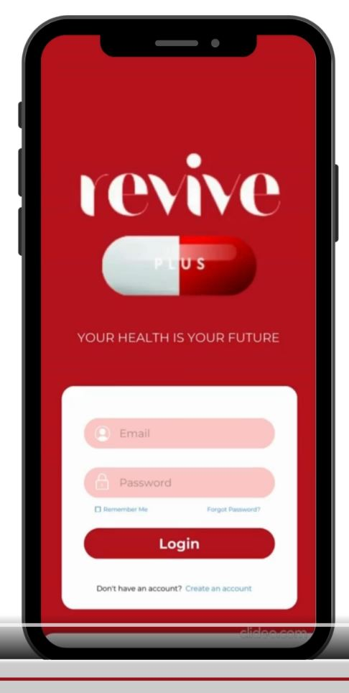

Key Features Highlights:

User-Friendly Interface: Take note of the clean and straightforward design that welcomes users upon arrival at the login page. We have emphasised simplicity and usability to create a positive visitor experience.
Users may easily enter their email and password to obtain access to their accounts. The "Remember Me" option makes returning users easier by simplifying the login procedure.
Account Set-Up: Those new to our site may easily create an account with a single click. "Don't have an account?" The "Create an account" option walks customers through the registration procedure easily.
Forgot Password: We realize how frustrating it may be to forget one's password. That is why we have added a "Forgot Password" link, which allows users to easily reset their credentials and restore access to their accounts.
Page 2:
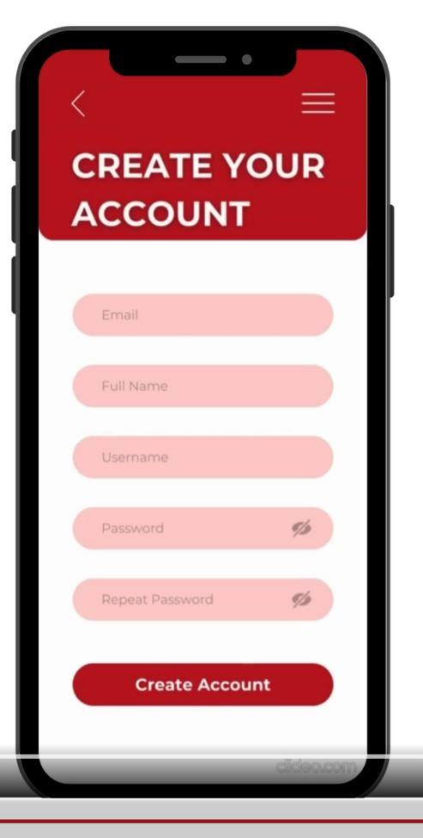
User-oriented Layout: Our goal is to make the account creation procedure as simple as possible. The bold "Create an Account" title captures users' attention and guides them through the registration process.
Simple Navigation: Notice the inclusion of recognizable navigation components like the back arrow and three-line symbol. This simple design allows users to easily explore new options or navigate back to prior displays.
Registration Form: To guarantee that we get all relevant information from users, we have included sections for email, full name, username, password, and repeat password. This complete strategy speeds up the registration procedure while adhering to security standards.
Automated Action: After entering their information, individuals may formally join our platform by clicking the "Go to Create Account" button. With a simple click, users may complete their registration and realize the full potential of our Revive.

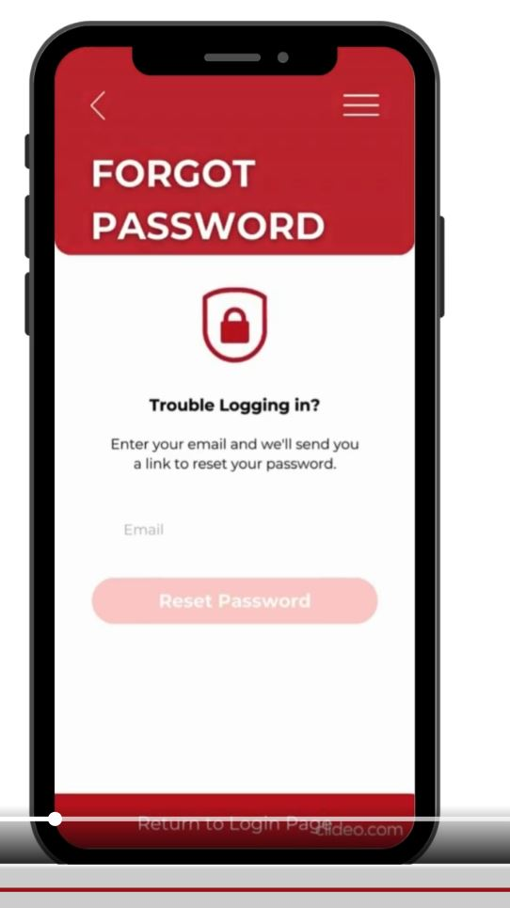
Easily accessible Navigation: Familiar navigation components, such as the back arrow and three-line icon, make it easy for users to return to previous pages or obtain further information.
Security Quality Control: The lock emblem in a secure shape represents our commitment to protecting your personal information. We prioritize security at every stage, providing your peace of mind while using our platform.
Simple Recovering Process: Users who are having problems signing in are greeted with a comforting message: "Trouble logging in?" Enter your email address and we will give you a link to reset your password." This basic method reduces customer irritation while promoting a favourable experience.
Speedy Reset Process: You may start the password reset procedure by entering your email address and clicking the "Reset Password" button. We designed this approach to be efficient and user-friendly, reducing downtime and allowing you to recover access quickly.
After requesting a password reset, users are automatically sent to the login page to utilize their revised credentials.

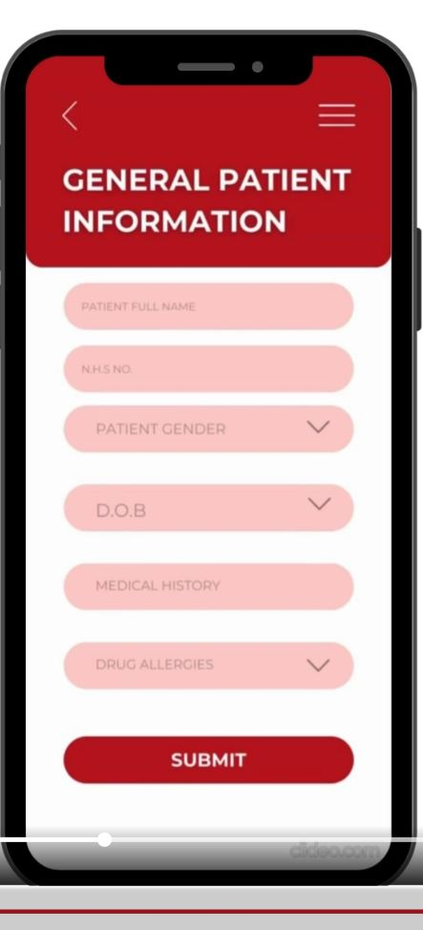
Organized Input Sections: Users are invited to provide important patient information such as their complete name, N.H.S. (National Health Service) number, and date of birth (DOB). Structured input fields improve data accuracy and speed up the information collection process.
Gender Picking: Our platform acknowledges a wide range of gender identities. The drop-down arrow allows patients to choose their gender from a list of preferences.
Date of Birth Selection: Using the drop-down arrow, patients may easily move around the calendar and pick their birthdate.
Medical History and Allergies: Patients are asked about their medical history and any pharmacological allergies they may have. The platform provides a list of common allergens for ease, with the opportunity to manually enter additional information if necessary.
Submission: Once all required information has been input, users may easily submit the form, ensuring that healthcare practitioners have access to correct and up-to-date patient data.

Page 5:
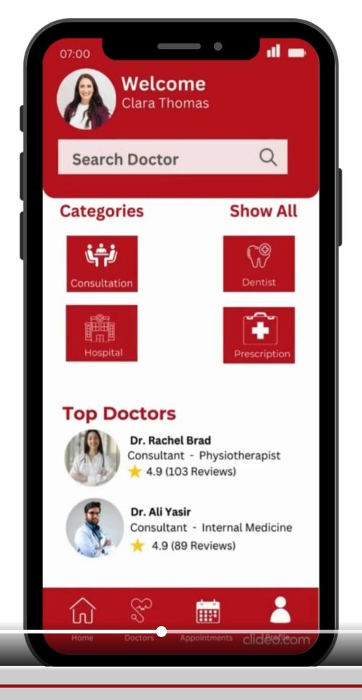

Personalized Greeting: Begin by greeting patients by name, ensuring a personalized experience from the minute they join the platform.
Search Functionality: The "Search Doctor" tool allows patients to easily find healthcare professionals by their name or specialization. This user-friendly search option makes it easier to identify the best healthcare provider for their specific requirements. Patients may choose from categories of healthcare services, including consultations, dental treatment, hospital services, and prescription fulfilment. Each category is designed to satisfy specific healthcare needs, providing patients with complete treatment and assistance.
Top doctors: By highlighting top-rated providers, people may make educated judgments based on the experiences of others. Patients can better understand the level of treatment they can anticipate when ratings are shown beside each doctor's profile.
Flexible Selection: Patients are free to pick the healthcare practitioner who best meets their requirements. Whether they are looking for a certain specialist or exploring new choices, our platform provides flexibility and choice.
Patients may readily access crucial navigation options at the bottom of the page, including "Home," "Doctors," "Appointment," and "Profile." These connections provide smooth navigation throughout the site, resulting in a more user-friendly experience.
Page 6:
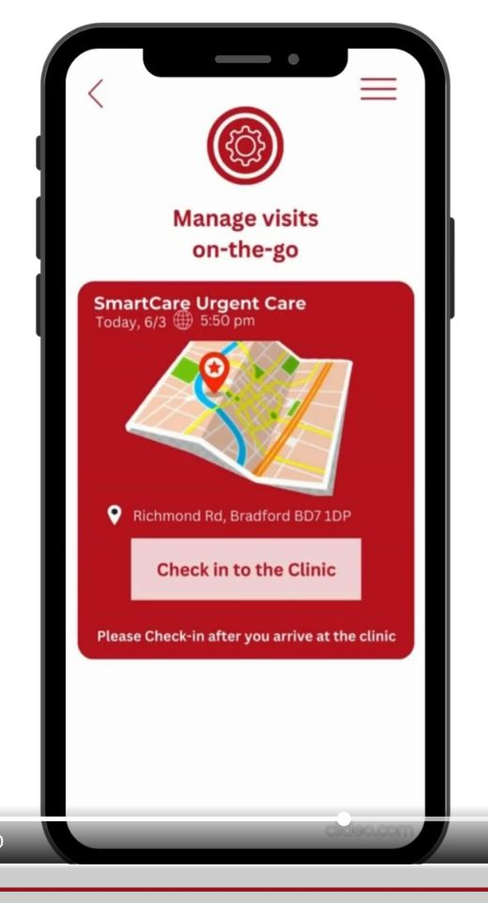
Location-Based Services: Using your location, our platform displays available clinics and physicians in your area. Whether you're at home or on the go, you can simply identify nearby healthcare professionals, guaranteeing convenience and accessibility.
Real-Time Availability: Find clinics and physicians who are available right now.
Convenient Check-In: When you arrive at the clinic, you may complete your check-in procedure with a single tap. The luminous pink box directs you to "Check in to the clinic," enabling a seamless transition from arrival to consultation.

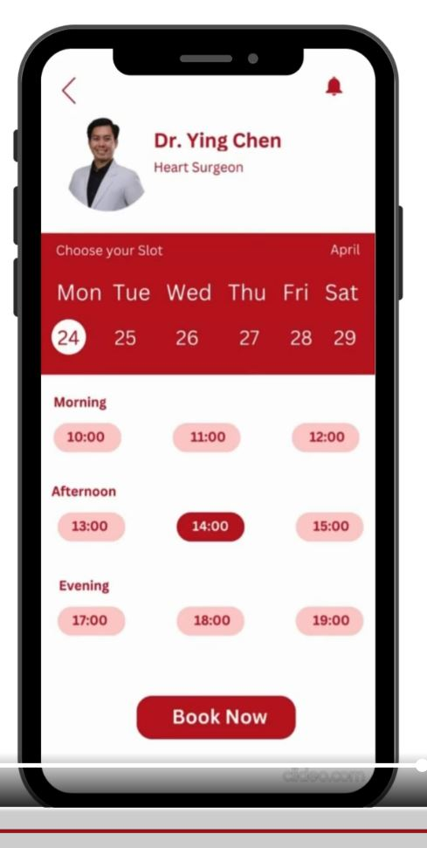
Doctor Selection: Begin by selecting the doctor with whom you want to arrange an appointment. Our platform includes information such as the doctor's name, specialization, and any other relevant information to assist you in making an informed selection.
Appointment Date: Use the calendar to choose your preferred appointment date. Whether you're planning or need quick assistance, our platform is designed to work with your schedule. Time Selection: Please provide your favorite appointment time depending on your availability. Choose from morning, afternoon, and night slots, then choose the time that works best for you.
Convenient Booking: Once you've chosen your doctor, day, and time, simply click "Book Now" to confirm your appointment.

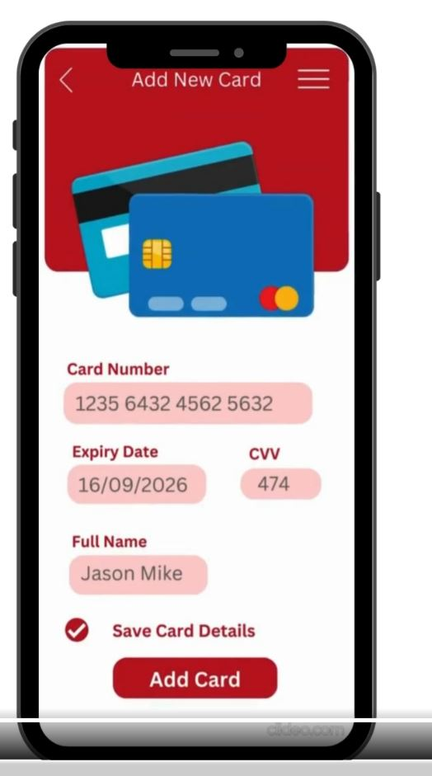
Card Details Input: Start by inputting your card information, which includes your name, card number, and CVV (Card Verification Value). To protect your sensitive information, our platform prioritizes data encryption and adheres to industry security standards.
Secure Transmission: Your payment information is securely transferred over encrypted channels to prevent unwanted access or interception.
Save Card Details: For increased convenience, you may securely keep your card information within the app.

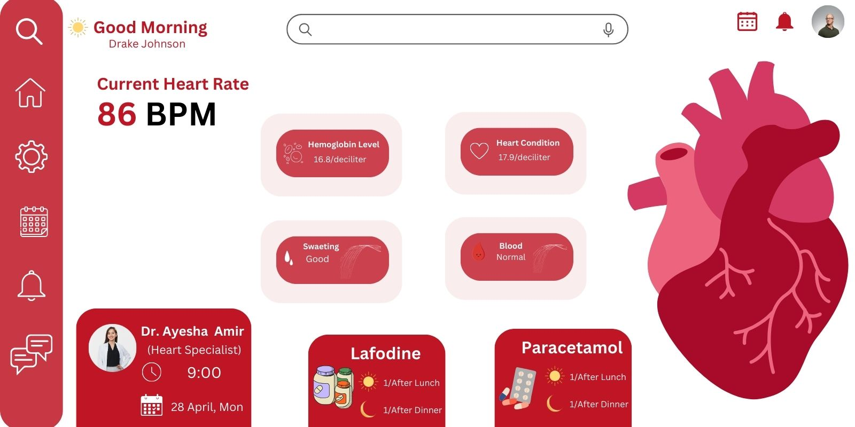
Personalised Greeting: Begin the day with a warm greeting suited to you. Our platform welcomes you with "Good Morning [Patient Name]" next to your profile picture, offering a personalized experience from the minute you log in.
Intuitive Navigation: Use the intuitive navigation icons on the page's left side to easily access crucial elements. Our AI chatbot in our revive app makes it easy to find information, manage appointments, and interact with it.
Complete Health Monitoring: Keep track of your state of health with real-time information on critical signs. Our Revive website keeps all your health information up to date and conveniently accessible, including anything from your current heart rate to hemoglobin levels and cardiac problems.
Appointment Management: Easily monitor your upcoming appointments. The left side of the screen displays information about your planned appointments, such as the doctor's name, specialization, and booking time.
Medication Reminder: Personalized medicine reminders ensure you never miss a dose. Our app has a special feature for reminders for morning, evening and nighttime medications, allowing our users to stay on track with their ongoing treatment.

REVIVE INTERFACE INTEGRATION PROCESS FLOW

Figure 2 Diagram showing AI Integration.

Figure 3 Diagram showing AI features.

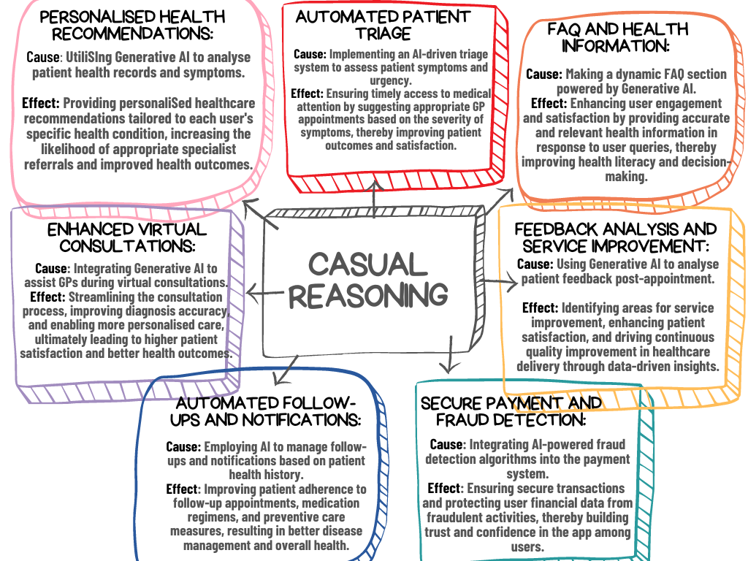

Figure 4 Diagram showing Causal reasoning.

Implementation
To successfully implement our product concept, as entrepreneurs, we first must define the strategies we will employ in ensuring that our plans are turned into actions to accomplish our objectives and goals. The Harvard Business review suggests that Founders become more convincing and credible to partners and investors when they demonstrate an idea’s potential using diverse strategies (Gans, Scott and Stern, 2018). Therefore, we will first employ the Entrepreneurial Strategy Compass to explore our strategic options.

Figure 5: ENTERPRENEURIAL STRATEGY COMPASS
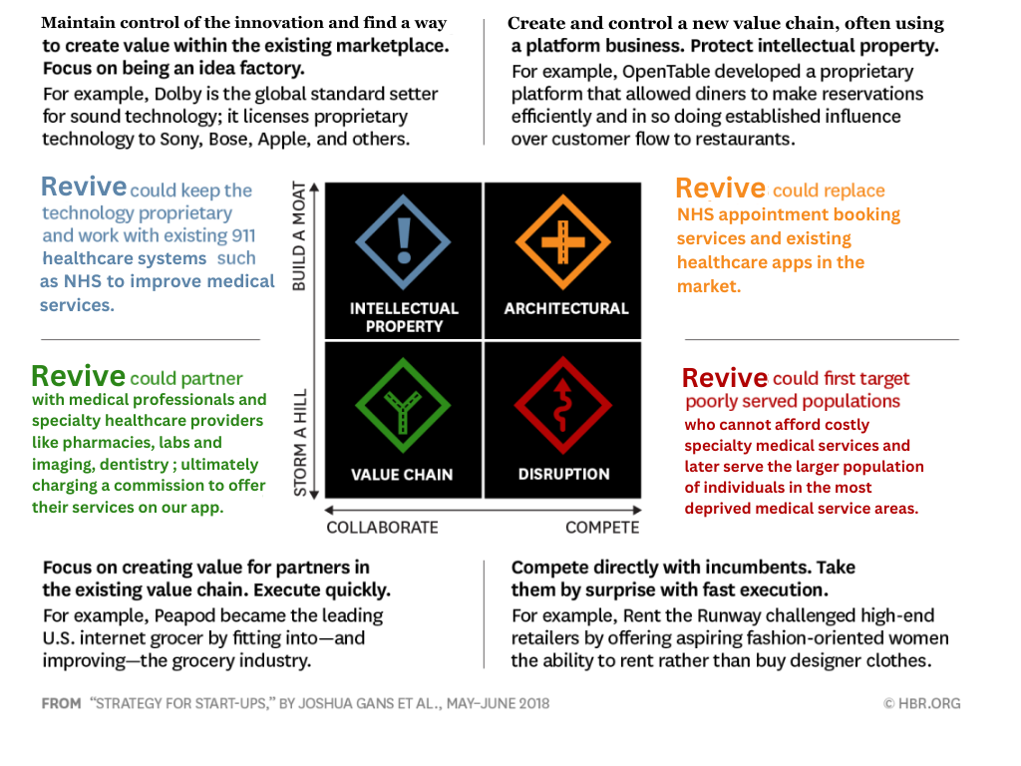

The Entrepreneurial Strategy Compass has four strategies:
The Intellectual Property Strategy
The Disruption Strategy
The Value Chain Strategy
The Architectural Strategy
From the strategy model above, we will adopt the Disruptive strategy, Architectural Strategy, and Intellectual Property Strategy. Because our concept competes directly with NHS and other health booking apps in the UK market and is creating new value in the healthcare industry through our app by providing access to affordable health care services that is cheaper than private care but better than the NHS and may replace existing medical booking services in future. Therefore, we will utilize all in our implementation.

We also came up with some questions to better understand our implementation strategy and refine it accordingly.

ASSUMPTIONS/QUESTIONS | OUTCOMES
Should we Collaborate or Compete? | The National Health Service (NHS) is the main healthcare system in England and is publicly funded (Chang et al., 2019; Gans, Scott and Stern, 2018).  Do we want to be in direct competition with the NHS or collaborate with them and the medical professionals?  Most experienced medical professionals in the UK are licensed under the NHS with a few engaged in the private health care sector.  (DHSC Media Team, 2023, NHS England, 2023)  How do we recruit them for our platform?  Proposed Solution: Develop a middle ground between the NHS and Private Health care that is competitive but collaborates with the NHS to offer better medical services. By doing so, the pressure currently faced by the NHS on the demand for medical services can be relieved.  Find ways to recruit medical professionals already engaged with the NHS in a way that doesn’t violate their contractual obligations.
Do we assume full control (Intellectual propriety) or utilize first movers’ advantage by collaboration with partners in this sector? | Should we aim to retain full control of our intellectual property (REVIVE app idea), if so, what are the costs associated with this and how does that affect the value we want to offer our customers?  If not, how do we align our services with partners ensuring compatibility with existing healthcare systems (Pharmacies like Health plus, dental care systems)

SWOT AND PESTAL ANALYSIS:
We used Techniques like SWOT (Strengths, Weaknesses, Opportunities, Threats) and PESTLE (Political, Economic, Social, Technological, Legal, Environmental) analysis for assessing our business plan's viability through evaluating its potential advantages, disadvantages, anticipating challenges, and making informed decisions. It's quite helpful for us to take an analytical approach to evaluate our idea in advance and identify what are the potentially internal and external factors which could affect the feasibility of our Revive App business idea.

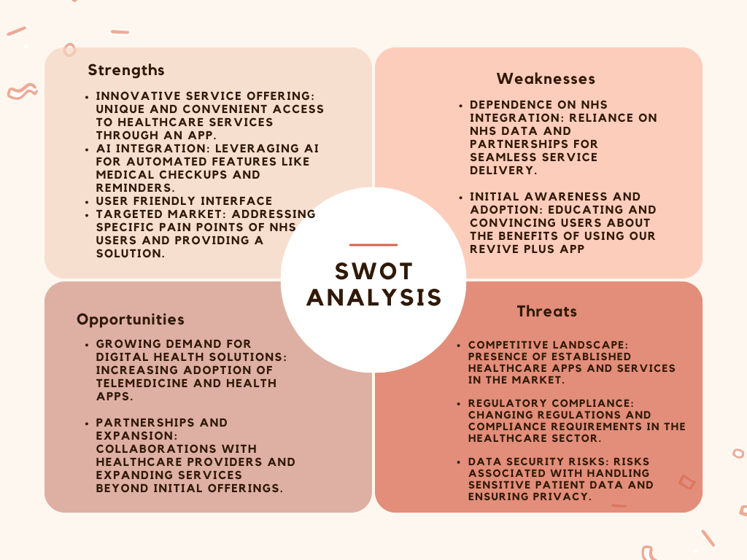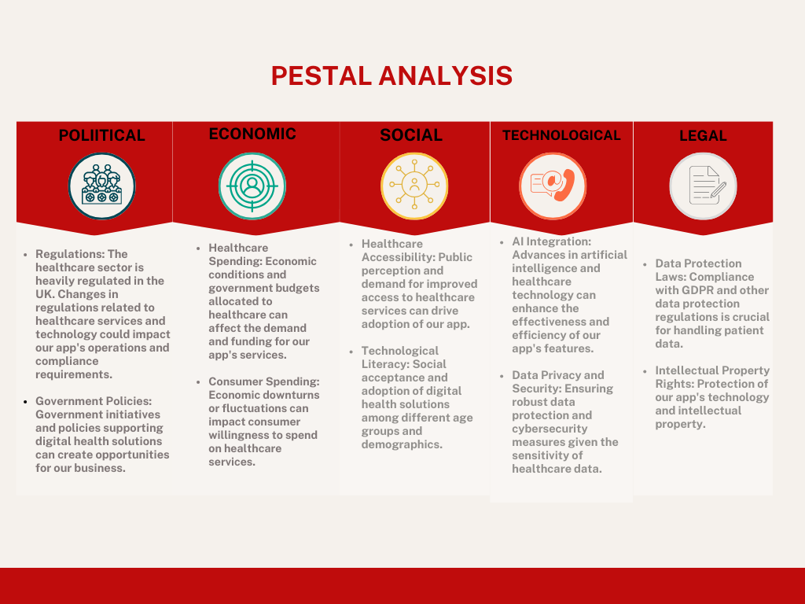
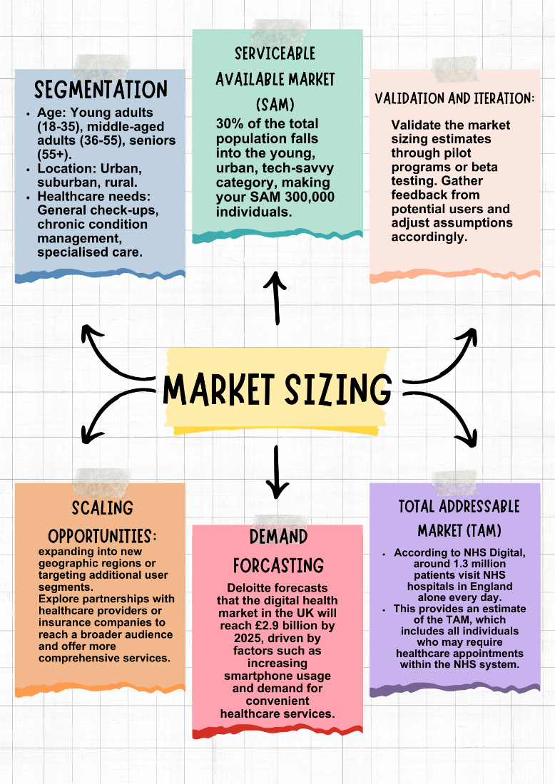

BUSINESS MODEL FOR REVIVE
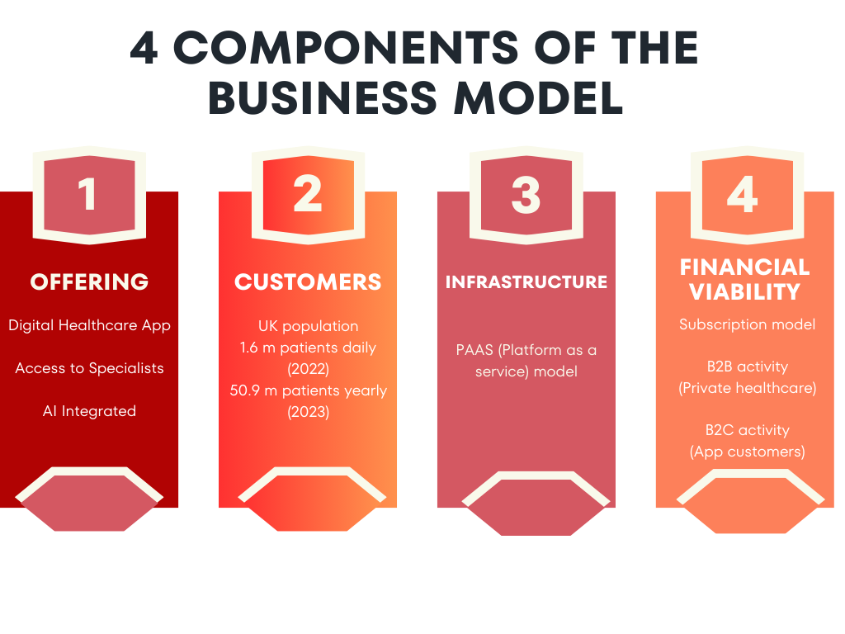

Offering
The key offering is a convenient way of users to access prompt healthcare services using an app that integrates a streamlined process of accessing various professionals in the healthcare field which are pediatrics, family medicine, gynecology and cardiology. As a significant number of the population in the UK face problems while accessing the NHS services, this service aims to remove those hurdles and ensure that individuals can focus on improving their health and wellbeing. The app will integrate artificial intelligence to include automated medical checkup reminders, triage, follow ups and notifications, and patient treatment and services feedback. This will improve the overall functionality of the medical booking system.

Customers (excel graph or table showing statistics of patients’ NHS services)
The analysis of our target audience from the market research into NHS services states that over 1.6 million patients utilized NHS services daily from medium medical cases such as flu, cold to more severe medical conditions like cancer, heart disease and mental health disorders in 2022. However, the number of medical practitioner appointments estimated at a staggering 50.9 million paled in comparison to the number of patients which were significantly higher in 2023.

Infrastructure
The app will be PAAS (Platform as a service model) that is secure in terms of users’ confidential data, scalable, and compatible with a wide range of operating systems to ensure accessibility of all potential customers. It also requires partnerships with General Practitioners across the UK for integration of schedules and partnering with the NHS as a legitimate entity authorized to give a platform to customers to access their services.

Financial Viability
As an integral component of every venture, this app idea must prove to be economically viable for entrepreneurs. As such, the group has identified the subscription model to be the most suitable according to the type of industry selected.
The costs associated with developing this venture primarily include app development, app maintenance, customer support, and marketing. The additional costs include compliance with the UK government as the app will be integrated with the NHS. This will bring the total accumulated costs to approximately £ 6000 for the service to become operational in the city of Bradford.

Revenue model
After careful consideration and discussion regarding the various revenue models, the subscription model was shortlisted. This is due to the nature of the business; a subscription model will ensure that the continuous and predictable revenue stream while also generating a recurring income that will be crucial in the inception stage for survival. The income generated from this model will also be critical in improving Revive’s overall experience, functionality, and the user experience. Subscribers will also be more likely to build a loyalty to the business, facilitating the overall perception of the business. By charging a subscription fee, the app can cover the operational costs while it simultaneously provides affordable healthcare to its customers. This will ensure the scalability and survival of the business in the long run. The business will use B2B marketing with private healthcare providers as a commission will be charged for each booking made by customers through the app and B2C through our subscribers.

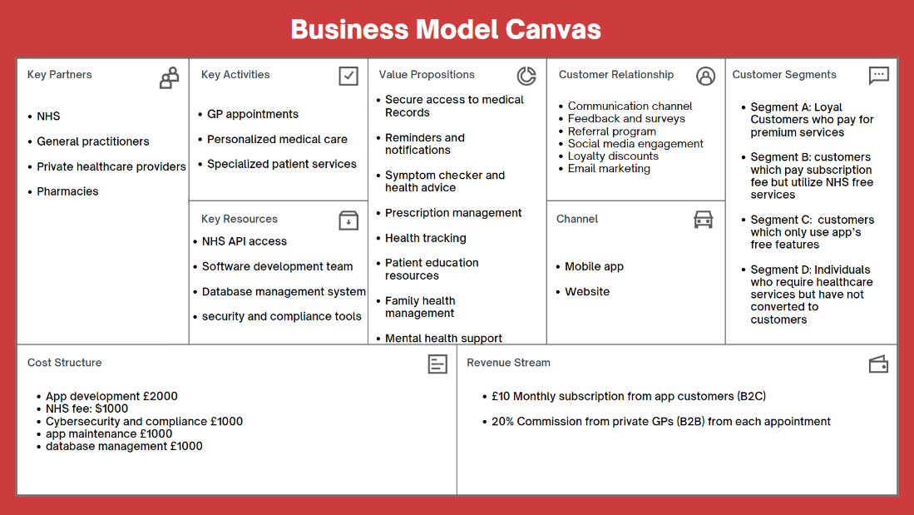

Scalability
When considering scalability of the app, it is vital to ensure it can accommodate increasing demand and usage from increasing customers while maintaining reliability, performance, and user satisfaction. The following factors will determine the scalability of the app:
- Concurrent Users: This will measure the number of users simultaneously accessing the app at a particular time. This will assess the app’s ability to handle a large volume of users while judging the performance.
- Response Time: Track the average time it takes for a patient to make an appointment, including time taken for the user to make a request and the subsequent response time from the app.
- Throughput: Calculation of how quickly the app can handle requests or transactions. This measure aids in determining how well the application can manage rising appointments and the number of interactions with the NHS.
- Scalability Ratio: Determine the ratio between the number of users or transactions and the utilization of resources (memory, and network bandwidth). This metric will aid in the identification of resource bottlenecks and evaluate the scalability of the app with increasing user demand.
- Error Rate: Keep track of the number of instances where users face errors when using the app. It is crucial to maintain a low error rate to ensure a seamless user experience and avoiding service interruptions to minimize bounce rate.
- Database Efficiency: Evaluation of the app database backend performance including query response times and efficiency of data retrieval. This will verify that the backend can handle increasing amounts of data and simultaneous access from various users.
- User Feedback: Customer feedback on the app’s usability, reliability and performance will be sought out. This feedback will be utilized to improve and refine the app which will aid in scalability.

B2B
B2C
Figure 6 Revenue model framework.
In 2022, a UK poll revealed a common issue creating major unhappiness among NHS users: excessive wait times for GP or hospital appointments. This was expressed by 69 percent of respondents, demonstrating widespread dissatisfaction with the availability of healthcare services. Furthermore, 55 percent of respondents named the NHS staff shortage as a major source of unhappiness.
The issue of long wait times has been worsened by a disturbing trend found in England during 2021. Data found that less than 80% of patients entering Accident and Emergency (A&E) departments were seen within the planned four-hour period, which is much lower than the NHS's guideline of 95%. The decrease in meeting the aim remained continuous since 2011, demonstrating a persistent difficulty in providing timely care. Furthermore, since 2016, there has been a significant increase in the number of patients waiting beyond twelve hours in A&E departments before being admitted, highlighting the strain on the healthcare system.
Another issue leading to increased pressure on healthcare systems is the growing patient load per General Practitioner (GP) in the UK during the last decade. The average number of patients per GP office has consistently increased, from less than 6.4 thousand in 2008 to more than 7.6 thousand in 2017. This rise shows that there is a larger demand for primary care services, which might result in longer wait times and reinforce perceptions of a staff shortage in the NHS.
Overall, these findings emphasis the critical necessity for solutions to address the rising demand for healthcare services, notably in terms of cutting appointment wait times and relieving pressure on NHS personnel.

Competitor analysis:
This involves examining the websites of important rivals in the healthcare business, such as Babylon Health, Push Doctor, and Zocdoc, providing useful insights into their unique offerings, features, and user feedback. Babylon Health offers a variety of digital healthcare services, most notably virtual consultations with healthcare specialists, symptom checker tools, and access to medical information. Push Doctor provides comparable virtual consultation services, emphasizing ease and accessibility via its platform. Additionally, Push Doctor offers same-day appointments and medication delivery services. Zocdoc, on the other hand, focuses on making it easier to plan appointments with healthcare providers by allowing users to search for doctors in their area, read patient reviews, and schedule appointments online. User evaluations on these sites give personal details of their experiences with the services offered, aiding in the assessment of user satisfaction levels and areas for improvement.

MARKET RESEARCH:
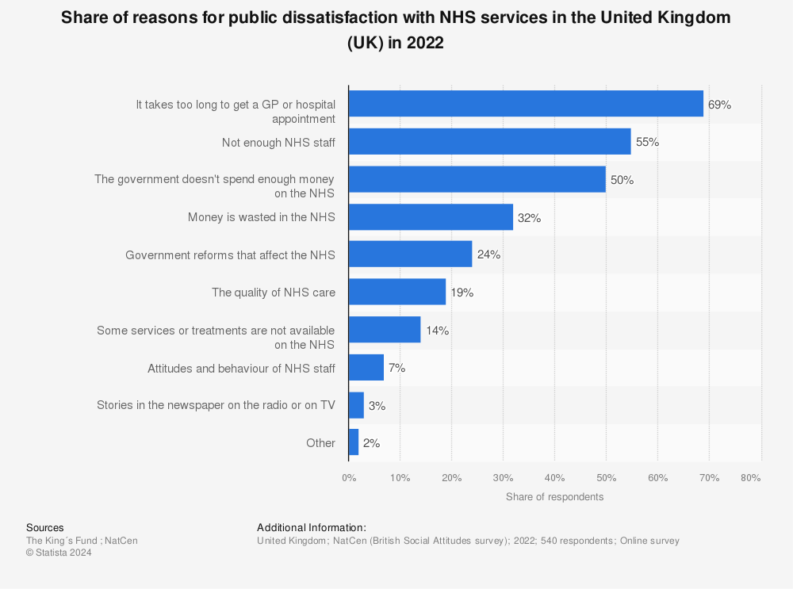
In 2022, a UK poll revealed a common issue creating major unhappiness among NHS users: excessive wait times for GP or hospital appointments. This was expressed by 69 percent of respondents, demonstrating widespread dissatisfaction with the availability of healthcare services. Furthermore, 55 percent of respondents named the NHS staff shortage as a major source of unhappiness.
The issue of long wait times has been worsened by a disturbing trend found in England during 2021. Data found that less than 80% of patients entering Accident and Emergency (A&E) departments were seen within the planned four-hour period, which is much lower than the NHS's guideline of 95%. The decrease in meeting the aim remained continuous since 2011, demonstrating a persistent difficulty in providing timely care. Furthermore, since 2016, there has been a significant increase in the number of patients waiting for more than twelve hours in A&E departments before being admitted, highlighting the strain on the healthcare system.
Another issue leading to increased pressure on healthcare systems is the growing patient load per General Practitioner (GP) in the UK during the last decade. The average number of patients per GP office has consistently increased, from less than 6.4 thousand in 2008 to more than 7.6 thousand in 2017. This rise shows that there is a larger demand for primary care services, which might result in longer wait times and reinforce perceptions of a staff shortage in the NHS.

Overall, these findings emphasis the critical necessity for solutions to address the rising demand for healthcare services, notably in terms of cutting appointment wait times and relieving pressure on NHS personnel.
Customer Survey
A survey was conducted among University of Bradford students to gauge the interest and determine how potential consumers feel regarding the practicality of Revive. A total of 99 responses were recorded.
Following is the link to the survey:
https://forms.office.com/Pages/ResponsePage.aspx?id=0aJeJGVDJkeAWmMeuT2TqlgVZvdR3gVBoMmC2xwMRR1UQjI4RFJUR0tPUUw4M1lUMzhMVlVWS05JRy4u
The results of the survey displayed that a majority of the respondents were not satisfied with the services offered by NHS and were willing to pay for a tailored solution to healthcare that Revive provides. The survey results can be illustrated in the pie charts below:
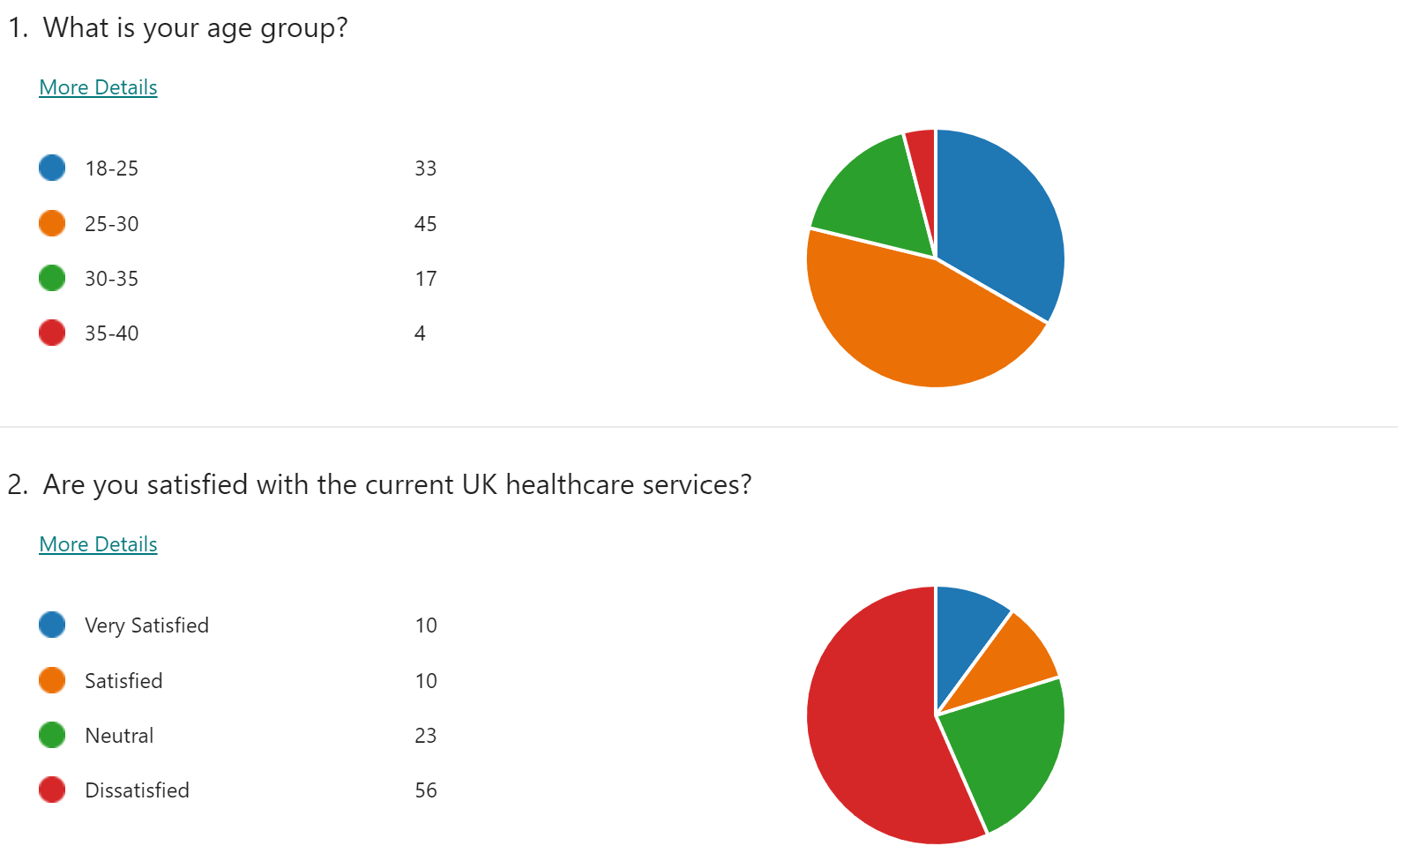
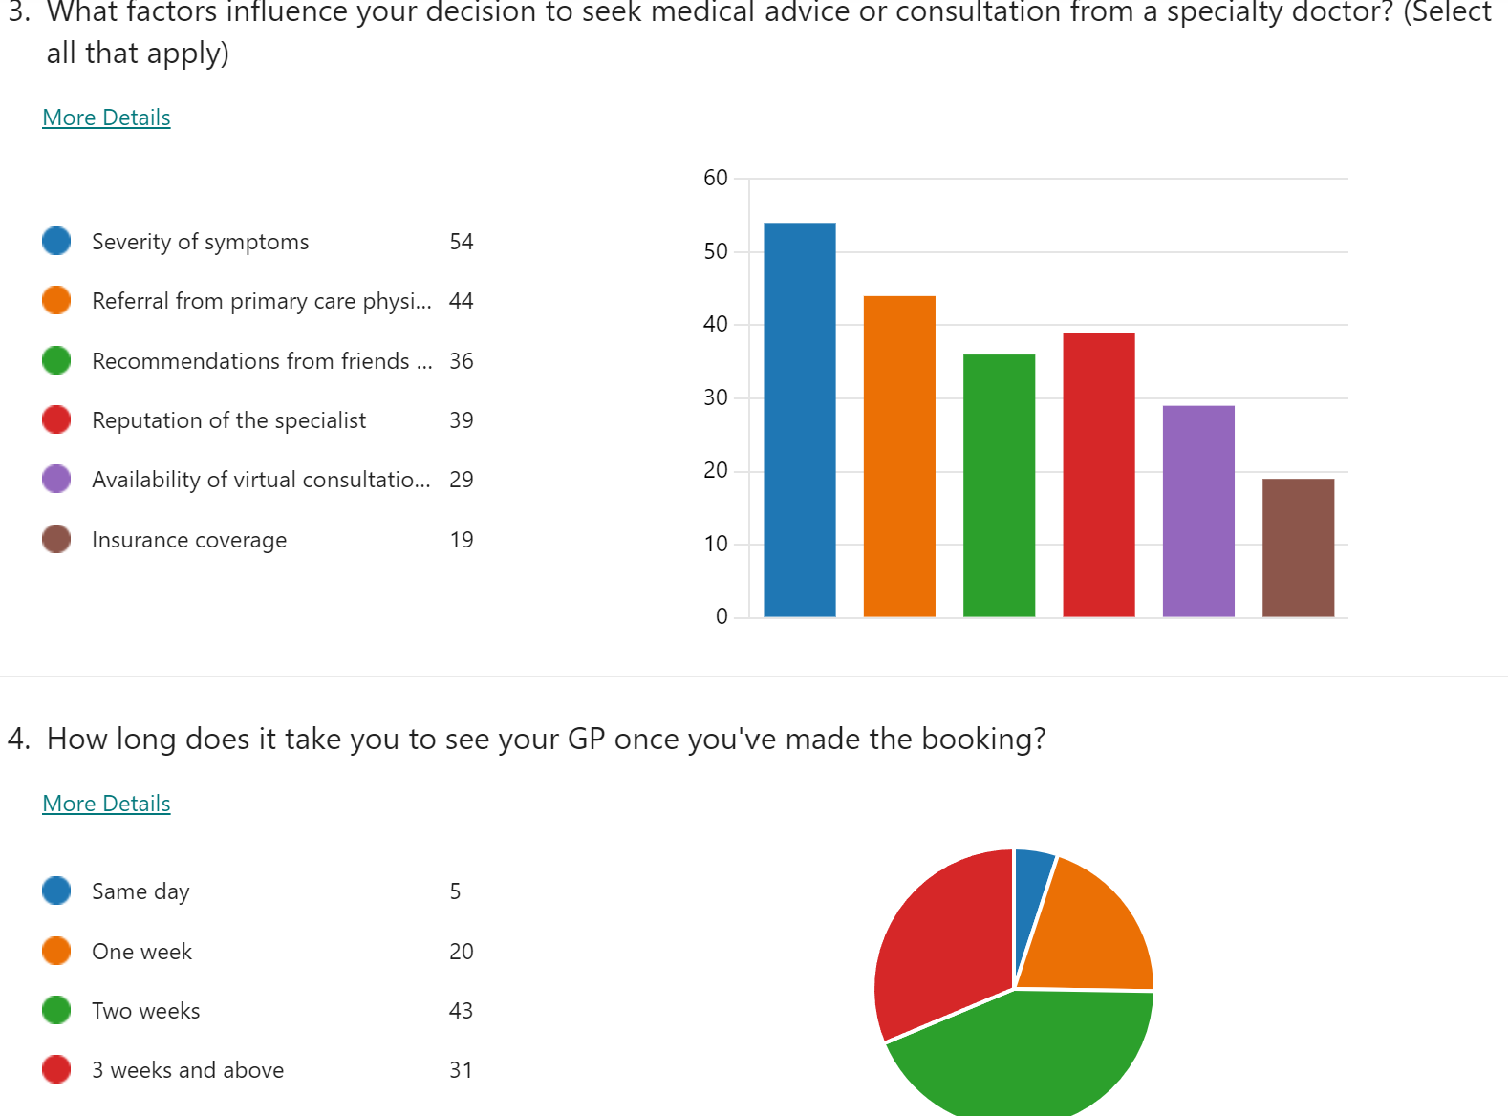
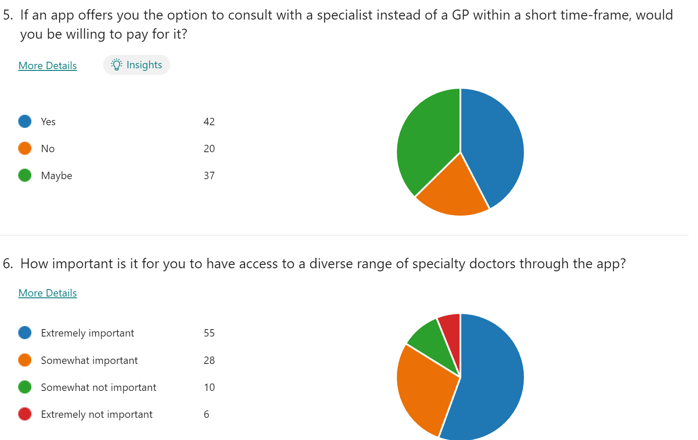
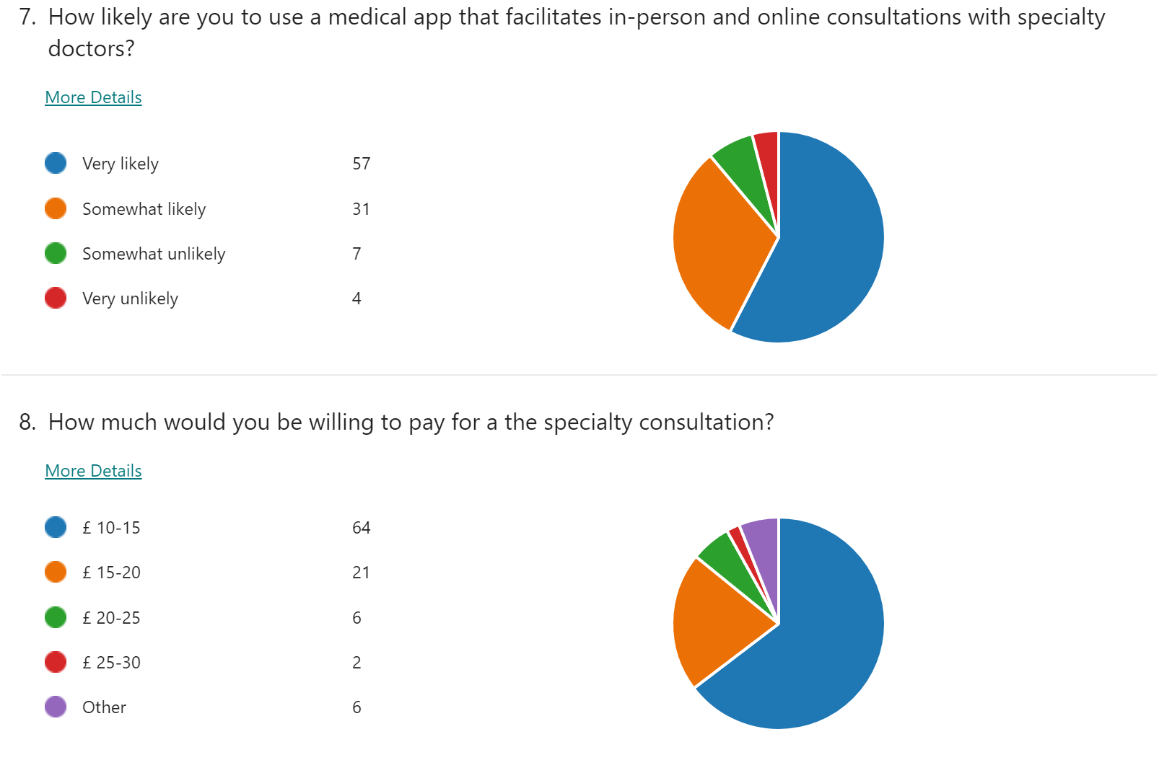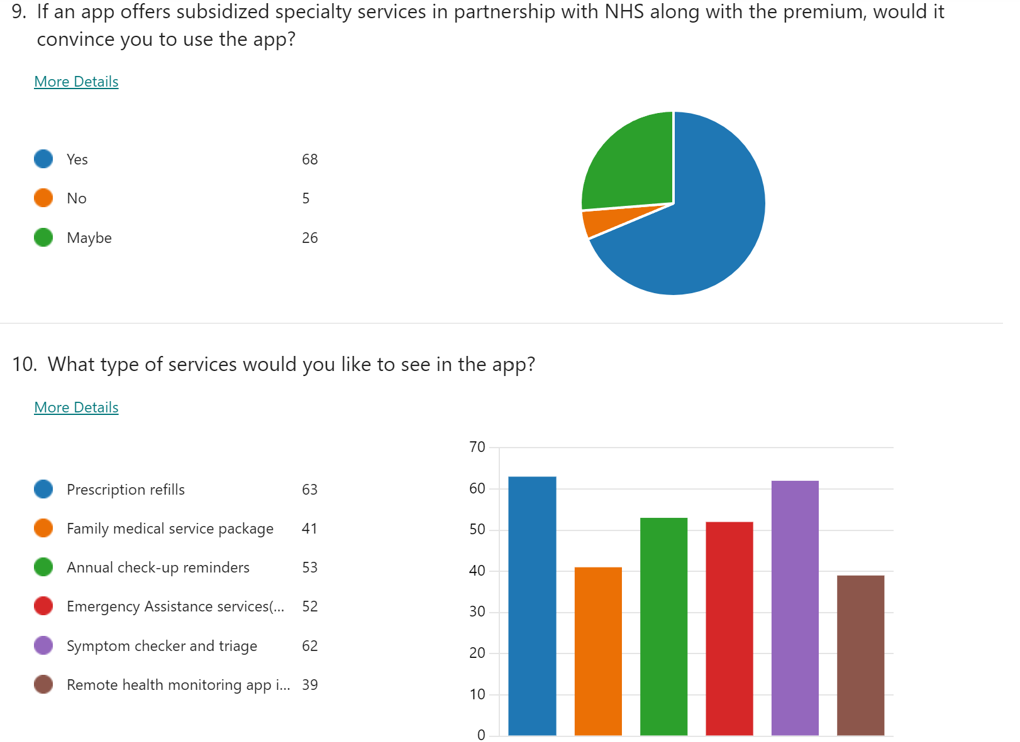

Market Size and Growth Projections:

Market analysis on digital health is provided by thorough Research. According to Frost & Sullivan's market study, the healthcare sector is expected to increase significantly over the next five years, with a compound annual growth rate (CAGR) of 8% (Frost & Sullivan, 2024). Moreover, Frost & Sullivan's analysis projects that the size of the global digital health industry will reach $379 billion by 2025, indicating a strong growth driven by advances in technology and a rise in healthcare digitisation initiatives (Frost & Sullivan, 2024). Additionally, Statista has comprehensive data that shows a consistent rise in the use of digital health, with an expected 78% of healthcare organisations putting digital health solutions into practice by 2024 (Statista, 2021). Sullivan & Frost, 2024.


Demographic | Insights
Age Distribution | - Younger demographics (18-34) are more tech-savvy and receptive to digital health solutions (Statista, "Digital Health Consumer Survey"). - Older age groups (55+) may exhibit slower adoption rates but still represent a significant portion of the user base (Statista, "Digital Health Consumer Survey").
Income Levels | - Higher-income individuals (annual incomes above £50,000) are more likely to invest in healthcare technologies and services (Statista, "Digital Health Consumer Survey").
Education Levels | - Individuals with higher levels of education (university graduates or postgraduates) are more likely to engage with digital health tools and platforms (Statista, "Digital Health Consumer Survey").
Geographic Location | - Urban areas have higher rates of digital health adoption compared to rural or remote areas. Regional disparities exist, with urban centers showing higher engagement levels (Statista, "Digital Health Consumer Survey").

PROPOSED SUBSCRIPTION PLAN
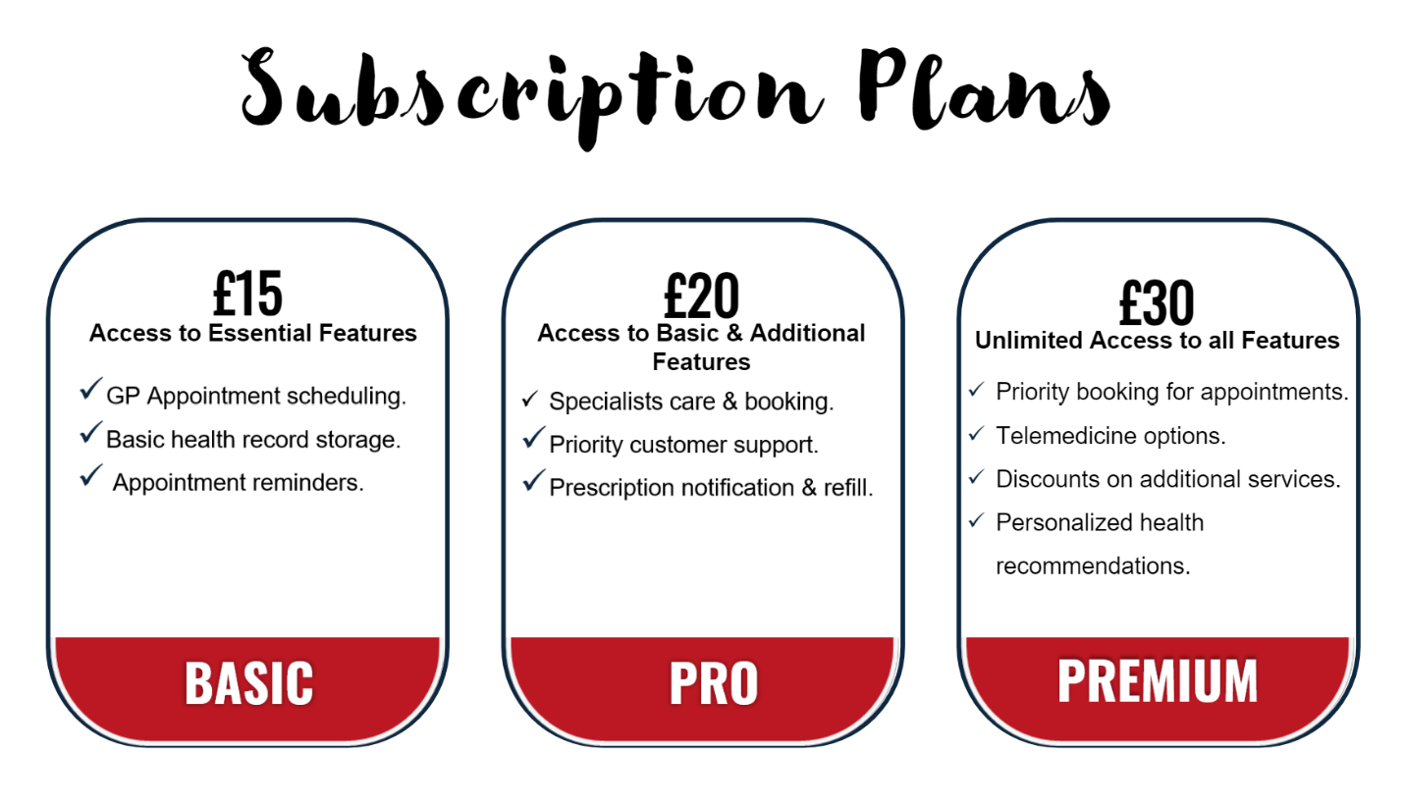

PROJECTED REVENUE
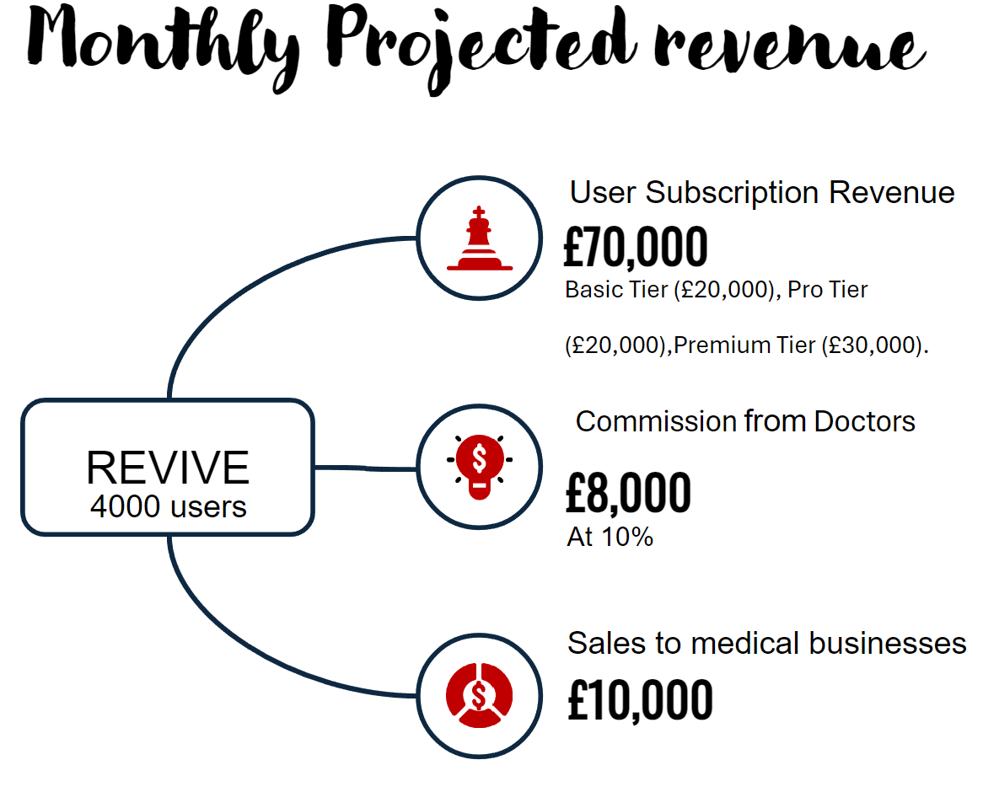

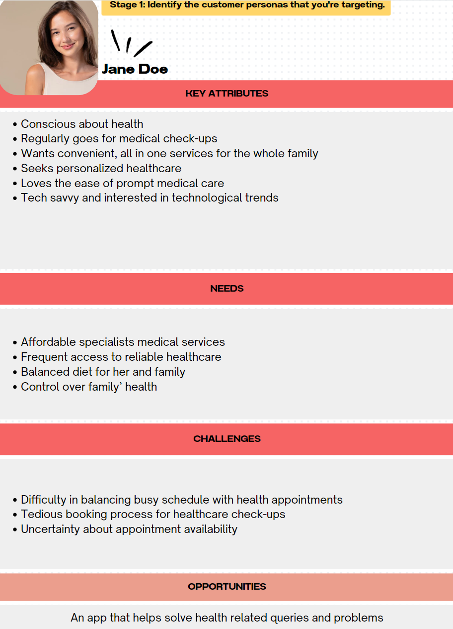

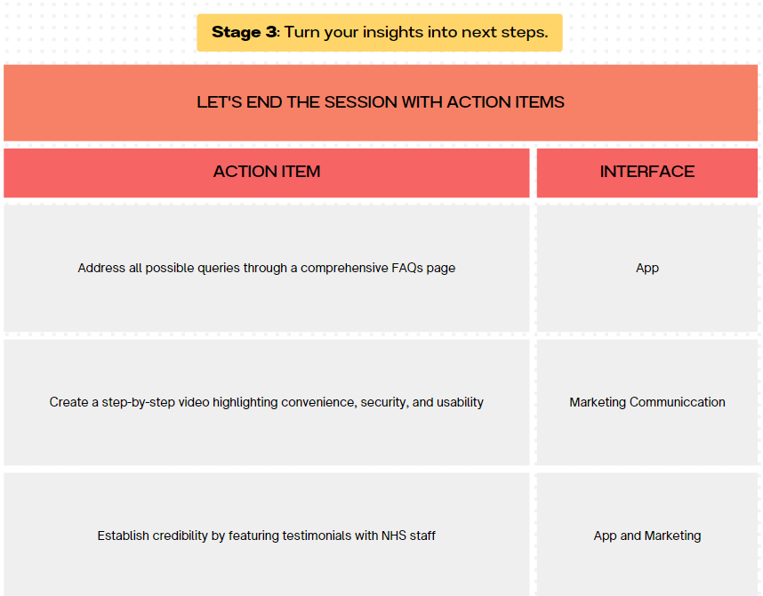

HOW REVIVE WILL PARTNER WITH NHS FROM A FINANCIAL STANDPOINT?
We hope to incorporate patient records and data from the NHS into the Revive app to justify our offering of free services by authentication following collaboration through NHS data access. This will involve several considerations like privacy regulations, and potential costs.
Firstly, Revive will negotiate a formal data access agreement with the NHS outlining the terms and conditions under which Revive can access and utilise patient records and data from the NHS. The potential costs will be of three types:
- Free or minimal charge: The NHS granting Revive access to patient records and data at no cost, viewing the collaboration to improve healthcare outcomes and alleviate pressure on NHS services. In this case, the data access agreement would not be monetized, and Revive would not have to pay the NHS for access to the data. Or the NHS may charge fees for data access and utilization to just cover basic administrative costs and ensure fair compensation for the use of NHS resources.
- Fee-based Access: Alternatively, the NHS may charge fees for providing access to patient records and data. These fees could be structured as one-time payments, ongoing subscription fees, or revenue-sharing arrangements based on the usage or revenue generated by Revive through the data access. In this scenario, the data access agreement would be monetized, and Revive would incur costs for accessing NHS data. (NOT PREFERRED)
- Value-added Services: Instead of direct monetary payments, Revive could offer value-added services or benefits to the NHS in exchange for access to patient data. Revive could provide analytics insights or tools to help the NHS better manage patient care or improve operational efficiency. In this case, the data access agreement will not involve direct financial transactions but would still be considered a form of monetization through the exchange of services.

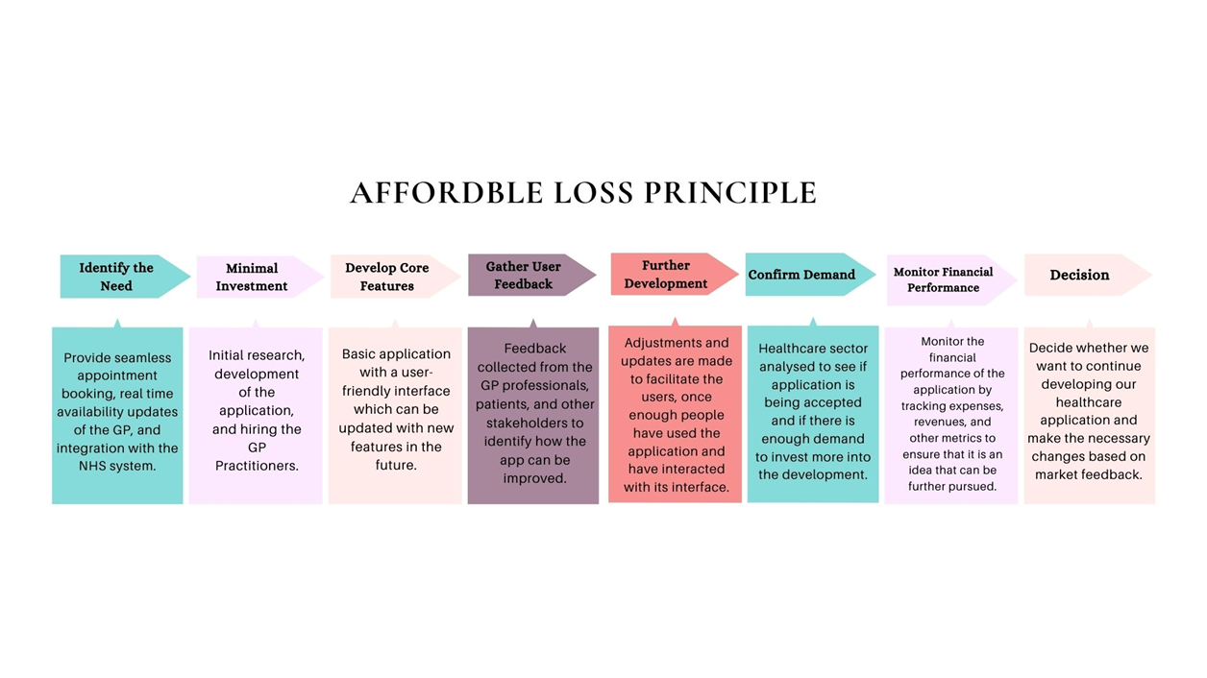
The Affordable loss principle suggests entrepreneurs must be prepared for the worst-case scenario in the business and should only put in what they can afford to lose. (Sarasvathy,2003). Therefore, we will make a basic application first with only the necessary features and then with time and customer feedback, we can add more features to it. Using this principle, we would be making our application using the least cost consuming way and preparing for the worst-case scenarios. This method would allow us to analyze all the risks we are putting on this new venture.
Start: Decided to start a healthcare application due to the problems people using the NHS long waiting lists face.
Identify the Need: It is important to know what issue we are going to be solving with our app. Our application will provide seamless appointment booking, real time availability updates of the GP, and integration with the NHS system.
Minimal Investment: In the initial stages, we will only invest in things that are only necessary such as initial research, development of the application, and hiring GP Practitioners.
Develop Core Features: Develop a basic application with a user-friendly interface which can be updated with new features in the future.
Gather User Feedback: Once the application is running, feedback will be collected from the GP professionals, patients, and other stakeholders to identify how the app can be improved.
Further Development: Using the feedback gathered, adjustments and updates are made to facilitate the users. This will be done once enough people have used the application and have interacted with its interface.
Confirm Demand: The healthcare sector is analyzed to see if the application is being accepted and if there is enough demand to invest more in the development.
Monitor Financial Performance: Then we will monitor the financial performance of the application by tracking expenses, revenues, and other metrics to ensure that it is an idea that can be further pursued.
Decision: At this stage, we will decide whether we want to continue developing our healthcare application and make the necessary changes based on market feedback.

Type of pricing strategy: fair pricing
We are going to be using the Fair pricing strategy. The demand and supply of the healthcare system should both be considered and then a price should be set. This means the costs incurred by us and the price the customers are willing to pay should be evaluated and an equilibrium should be reached. Setting a fair price is very necessary so that our business can cover all its expenditures related to the app and the healthcare practitioners, without compromising on the quality. (Barber et al, 2019)

CHALLENGES THAT MAY OCCUR (OVER BOOKING AND RATIO OF PROFESSIONALS TO APP SUBSCRIBERS.
Creating an application comes with it risks and problems. Some things we need to make sure are the traffic of users.If there is high volume of users on it, it does not crash or start creating issues for the users, which will lead to users getting frustrated and uninstalling the app. Moreover, the application needs to have a capacity to cater for an increasing number of users. Having the right number of GPs available for consultation is necessary to ensure a smooth experience for the users. For that, a number of backup professionals should be ready for any unexpected leaves or absences from the on-call GP.
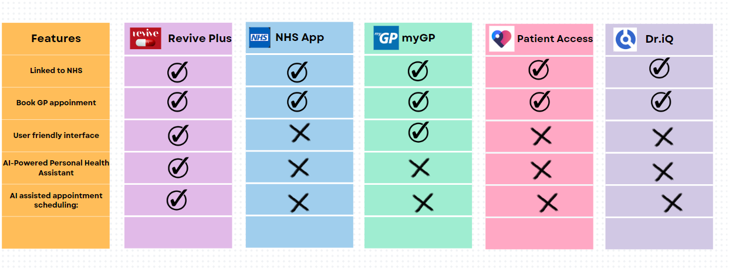

After doing some research to try to find competitor apps, we found some similar applications. However, none of these applications integrates Artificial Intelligence at the time. We believe that any product, even slightly similar to ours, is a competitor. A few examples of similar competitor apps are:
- NHS APP: This official NHS application allows patients to book vaccination for flu and coronavirus. Additionally, users can book GP appointments on this app, order their usual prescriptions by selecting a pharmacy near them and access their past health related concerns. After analyzing feedback of users on Google play store, people had complained that when they switched their doctors, the app erased all their previous medical records. Some users complained that the app lagged a lot and took a long time before anyone helped them. (NHS Digital,2019)
- Patient Access: This application is in partnership with NHS and allows users to book online or in person appointments with GP or nurses. It also offers vaccinations for flu and ordering prescribed medicines. It has recently updated its app and now users can download the app and use it to search their symptoms without linking the app with their NHS account. Users of this app have issues with the interface such as difficulty logging in and verification problems. (EMIS Group PLC, 2024)
- Dr.iQ: Another competitor app that is linked with NHS. The facilities this app offers are self-help, online consultations and access to patients’ history of medical records. In the Online Consultation tab, there are options for general advice, dermatology, gynecology, and muscular problems. The main aim of this app is to take away face to face appointments and long phone queues by just meeting online. Most of the dissatisfied customers have reviewed it as being a useless app which never works. (AT Tech, 2022)
- MyGP- Book GP Appointments: Using this app, users can book GP appointments as the app partners with NHS. Book appointments with GP and keep a track of medical records like results, conditions and past consultations (iPLATO Healthcare Ltd, 2016)

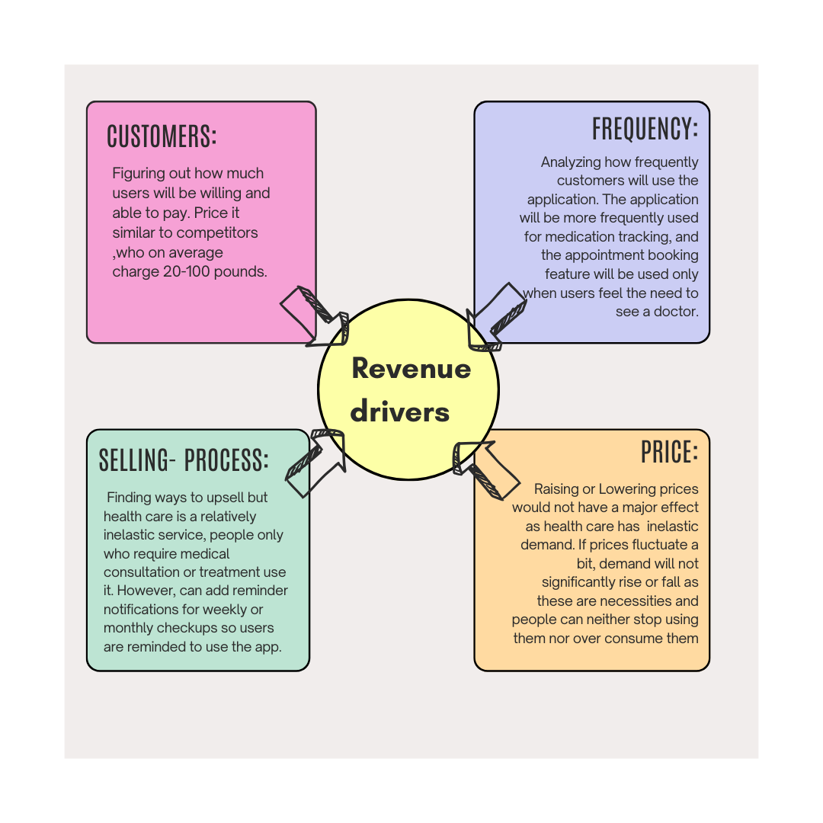

REVENUE DRIVERS
Choosing the right revenue model is necessary to reach the right target market and to make them use the product. As discussed before, we will be using the subscription model for our business. The key components of revenue drivers are Customers, Frequency, Selling process and Price.
Customers: In this part, we must evaluate how much our application users would be willing and able to pay. The customers of our business are the users of our application. They would be willing to pay similar to how much is charged by the competitors as on average, health care apps charge 20-100 pounds, depending on the type of consultation and process.
Frequency: Here we analyze how frequently customers will use the application. The application will be more frequently used for any medication tracking and ordering, and the appointment booking feature will be used only when users feel the need to see a doctor.
Selling- process: A business always must find ways to upsell its product or maybe provide other complementary products. As we are talking about healthcare, which is a relatively inelastic service, people only who require medical consultation or treatment use it therefore upselling cannot be a huge opportunity. However, it can be done by adding reminder notifications for weekly or monthly checkups of users, so they are reminded to use the app.
Price: Lastly, we need to know how changes in prices can affect our consumer behaviour.Raising or Lowering prices would not have a major effect as health care has more of an inelastic demand. This means that if prices fluctuate a bit, demand will not significantly rise or fall as these are necessities and people cannot stop using them or even over consume them in the case of a price fall.

Type of pricing strategy:
We are going to be using the Fair pricing strategy for our business model. The demand and supply of the healthcare system should both be considered before setting a price. This means the costs incurred by us and the price the customers are willing to pay should be evaluated and an equilibrium should be reached. Setting a fair price is necessary so that our business can cover all its expenditures related to the app and the healthcare practitioners, without compromising on the quality. (Barber et al, 2019)





REFERENCE LIST
AT Tech. (2022). Driq. Available at: https://play.google.com/store/apps/details?id=com.attech.attech_android_1.driq.
The King’s Fund. (n.d.). Activity in the NHS. [online] Available at: https://www.kingsfund.org.uk/insight-and-analysis/data-and-charts/NHS-activity-nutshell.
GOV.UK. (n.d.). 50 million more GP appointments delivered by the NHS. [online] Available at: https://www.gov.uk/government/news/fifty-million-more-gp-appointments-delivered-by-the-nhs#:~:text=In%20the%2012%20months%20to.

Chang, J., Peysakhovich, F., Wang, W. and Zhu, J. (2019). The UK Health Care System. [online] Available at: http://assets.ce.columbia.edu/pdf/actu/actu-uk.pdf.
DHSC Media Team (2023). NHS workforce: Record numbers of doctors and nurses in NHS - Department of Health and Social Care Media Centre. [online] healthmedia.blog.gov.uk. Available at: https://healthmedia.blog.gov.uk/2023/04/27/nhs-workforce-record-numbers-of-doctors-and-nurses-in-nhs/.
EMIS Group PLC. (2024). Patient Access. Available at: https://play.google.com/store/apps/details?id=uk.co.patient.patientaccess&hl=en_GB&gl=US&pli=1.

Gans, J., Scott, E.L. and Stern, S. (2018). Strategy for Start-ups. [online] Harvard Business Review. Available at: https://hbr.org/2018/05/strategy-for-start-ups.
iPLATO Healthcare Ltd. (2022). MyGP. Available at: https://play.google.com/store/apps/details?id=net.iplato.mygp.

NHS England (2023). NHS Workforce Statistics - January 2023 (Including selected provisional statistics for February 2023). [online] NDRS. Available at: https://digital.nhs.uk/data-and-information/publications/statistical/nhs-workforce-statistics/january-2023.
NHS Digital. (2019). NHS App. Available at: https://play.google.com/store/apps/details?id=com.nhs.online.nhsonline.
UK health systems (2015). UK health systems. [online] Health Careers. Available at: https://www.healthcareers.nhs.uk/working-health/uk-health-systems.

Golden investment prospect for savvy investors"

